Microsoft Sales Application
Volume Licensing User Guide

http://microsofteref.books24x7.biz
Table of Contents

Home Page 2
Top Navigation 2
My Recently Updated Accounts 2
Search for a user or account 3
Set up a new account 4
Upgrade a Trial Account to Paid 5
Registering users into a Subscription 5
Microsoft admin registers the users 6
Company admin registers the users 6
Microsoft admin sets up self registration page 6
View account info for existing subscription 7
Edit an existing trial or paid subscription 8
Add Notes to the Account 8
Find Users in an Account 8
Add Users to an Account 9
Enable Self-Registration 10
Set Advanced Account Configurations 10
Edit User Info 11
Resend a user’s password 11
Change a user’s email address 11
Delete a User from the Subscription 12
Change the administrator of a subscription 12
Make a User a Corporate Folder (CFA) or Corporate Topic (CTA) Administrator 13
Give User access to the User Reporting Site 13
Run reports for a subscription 13
Report Index 14
Subscription Detail - Subscription Usage Report 14
Subscription Summary - Summary of Usage Statistics 14

The URL to access the application is http://microsofteref.books24x7.biz. You will need to login with the username and password given to you.

Home Page

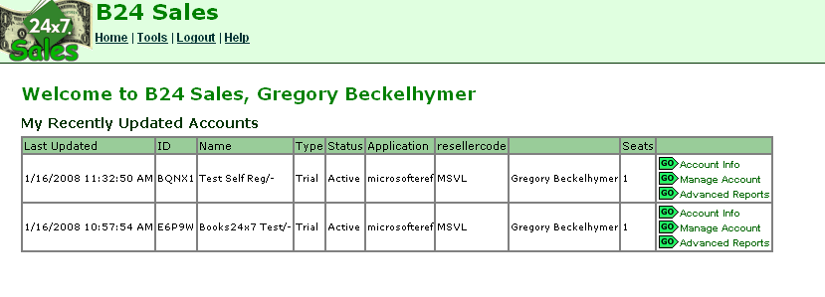

Top Navigation
Home – Takes you back to the Home Page of the Sales Application
Tools – Allows you to find an account (to edit or view it) or create a new account.
Logout – Allows you to logout of the system
Help – This is the online help document.

My Recently Updated Accounts
This list shows the most recently updated accounts for which the person logged into the site is the Salesperson.

The account listings consist of:
Date Last Updated
Sub ID/Account ID
Company Name and Department
Type (Paid or Trial)
Status (Active, Expiring or Inactive)
Application will always be microsofteref
Sales Group or Reseller Code will always be MSVL
Salesperson
Seats (total number of users in that particular subscription)

Next to each account, there are buttons that link to the following:
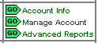
Account Info – see “View account info for existing subscription”
Manage Account – see “Edit an existing trial or a paid subscription”
Advanced Reports – see “Run a report for a subscription”

Search for a user or account
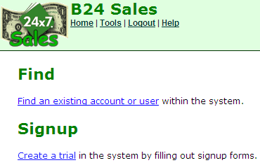
If the account you are looking for is not listed on the homepage, as a recently updated account, you will need to search for it. In order to search for a user or an account, click on “Tools” in the top navigation bar.

Then click “Find an existing account or user”

You can search by Account/Company Information or by User Information.
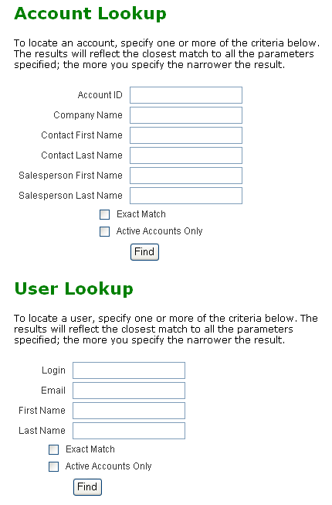

“Exact Match” restricts the search to the exact term(s) specified. For example, search on Company Name “Lockheed” and check exact match, you will not find subscriptions with the company name Lockheed Martin. Conversely, if you know the exact company name, you will not need to cull through as many results if you select Exact Match.

“Active Accounts Only” restricts the search to active trial and paid subscriptions. Using this option when doing a user lookup will restrict the results to users within active accounts, but it will exclude users that have been deleted.

Set up a new account
In order to set up an account you need to create a trial first. If you want to convert the trial to paid that is a separate step.

- Click on “Tools” in the top toolbar
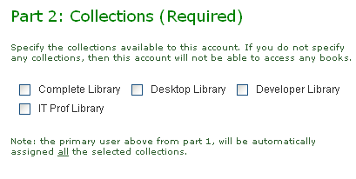
- Under Signup, click on “create a trial user”.
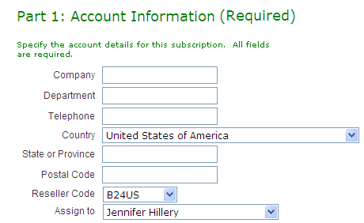
- Fill out Part 1 with the account information.
- Choose the proper collectionsfor the account in Part 2

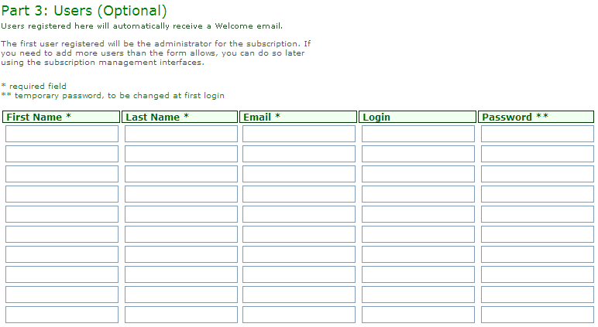
- If you would like to register users into the account, and have the system send welcome messages, fill out Part 3 with the users’ information. (If you do not want to send welcome messages, do not register the users here, register users on the Manage Account page and deselect Send Welcome.) You can also choose the self reg page option or have the company admin add users.

- Click Submit

The system by default creates a trial for 30 days on http://microsofteref.books24x7.com.

Upgrade a Trial Account to Paid
To upgrade a trial account to paid, lookup the account and go to the Manage Account page.
- Check the collections that were purchased in the Adjust Collections section.
- In the Convert Trial section, confirm the duration, set the number of User seats (the total number of users allowed in that particular account) and deselect any users from the trial that should not have continued access with the paid account.
- Be sure to check “Convert Trial into a Paid subscription” before clicking Update.

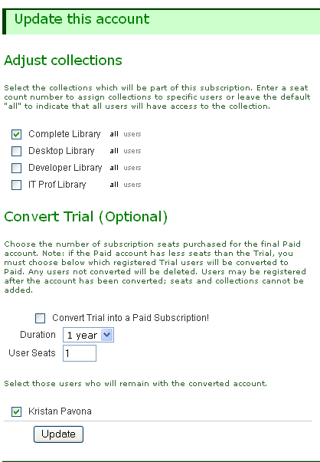

Registering users into a Subscription
There are three ways to register users into a subscription once the subscription is created:
- The Microsoft admin can register users via the sales application (for small subscriptions)
- The Company admin can register users via their account page when they login (for smaller subscriptions)
- The Microsoft admin can create a Self Reg page that the company admin can send out to users (for larger subscriptions)

Microsoft admin registers the users
The Microsoft admin can add users to a trial or a paid subscription in the manage account area (see add users to an account on page 9).

Company admin registers the users

The Microsoft admin will need to set up one user in the subscription to be the administrator of the subscription. The person who is filled in on Part 1 of the signup page will be the administrator as the default. The admin of the subscription can be changed at any time (see page 12).

Microsoft admin sets up self registration page

The Microsoft admin can set up a self registration (for a trial or paid subscription) for the users. The Microsoft admin can do this via the Manage Account page. (See page 10 for instructions). The Microsoft admin will be required to send the URL to the Company admin to send out to the users.

The self registration page will look like the following:

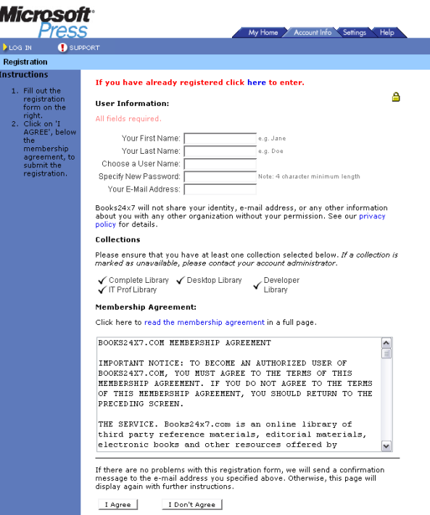

View account info for existing subscription
The Account Info page allows you to view the information for a particular account. It shows the main subscriptions information including any special subscription settings
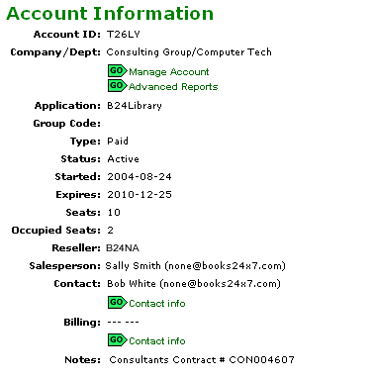

The collections available to the account are listed below the general info. “Seats” is the number of licenses purchased of that collection.
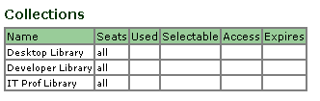
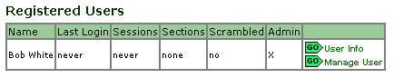
This page includes a list of users with admin, CFA or reporting rights. The list may also include the accounts top users (based on activity) for the subscription, and their stats.

If there is a very large subscription, you will not be able to see all of the users here. If you need to find an individual in a large account, use the search form on the Manage Account page.

Edit an existing trial or paid subscription
The “Manage Account” section is where you go to edit an account that has already been created.

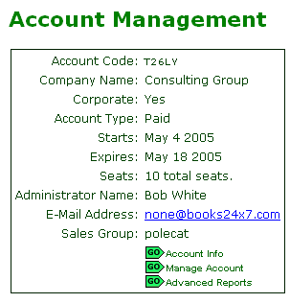
Here you have the option to:
Manage User Collections
Add Users to the Account

General account info:

Find Users in an Account
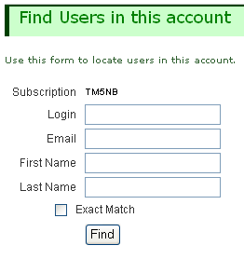
After looking up the account, go to the Find Users in this Account section of the Manage Account page. Use this search box to lookup users in this subscription only. “Exact Match” restricts the search to the exact term(s) specified. For example, search on login “tech” and do not check exact match, you will find users with logins of techbooks, technology, mytech, etc

Or you can search for a user in any account by clicking on “Tools” in the top navigation bar.
Then click “Find an existing account or user”

Add Users to an Account
Here you can add additional users to an active trial or a paid subscription. If you add more users to the trial the seat count will be automatically adjusted to accommodate. For paid subscriptions you will not be able to add more users once the seat count has been reached.
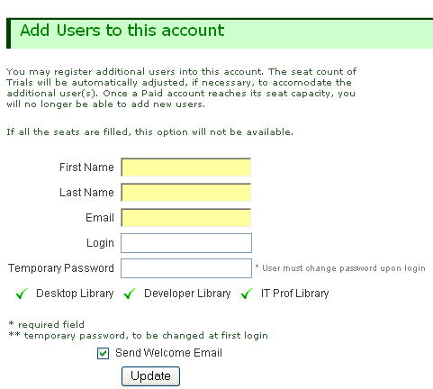

The user’s first name, last name and e-mail are REQUIRED. If you do not put in a password the system will automatically generate one for you. If you uncheck the Send Welcome Email box, the user WILL NOT be sent an email with their username and password.
All Passwords specified here are temporary passwords, meaning when the user logs in for the first time they will be prompted to change it.
Enable Self-Registration

In accounts where there is a large amount of users, using a self-registration form will often be the simplest mode of deployment.
- Check the Enable Self Registration option, and add the email domains (ie. Microsoft.com) that will be allowed to register within the subscription to set up Self Registration for the account.
- The Self Registration URL will then be displayed. This is the URL that the Microsoft admin needs to send on to the Customer admin. The Customer admin will then need to send it out to the appropriate user audience to register.

Only users that own email addresses with the domains in the system will be allowed to register (an email will be sent to the user with the login information after the user completes the registration form)
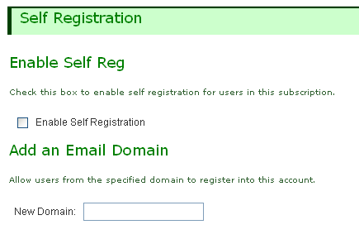
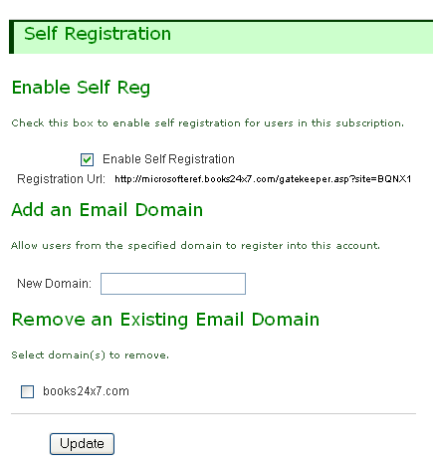

If for any reason a domain must be removed, check the box next to the domain to be removed and hit Update. Note – this will not affect users already registered into the account, it will only limit new registrations.

To disable the registration form, uncheck the box next to “Enable Self Registration”, and click Update.

Set Advanced Account Configurations
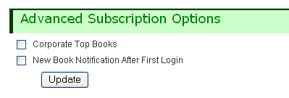
There are a few site options that clients might like to take advantage of. If a known option is not listed in the application, you will need to contact Books24x7.

Add Notes to the Account

After looking up the account, go to the Add Subscription Notes section of the Manage Account page. Subscription notes can be added to using this form and will be visible to any person that looks up the account within the Sales Application. Please note, previous notes cannot be edited or removed.
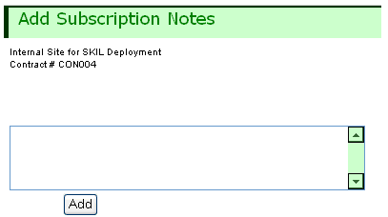

Edit User Info
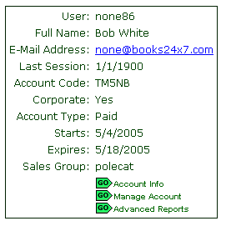
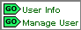
After looking up a user, click on User Info to see all the vital stats on that user. Click on Mange User to edit any of that information.

Resend a user’s password
On the Manage User page, go to the section that says “Email user password” and click Send.
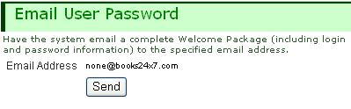

Change a user’s email address
For users that access the Books24x7 site directly, that have never logged in before, you may be able to “fix” their email address. After looking up the user, go to the Manage user page and look for the Fix User Email section.

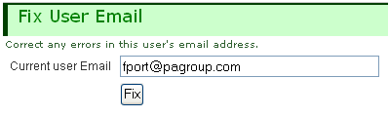
- If it is available, enter the desired email in the box and click Fix.

Please note, users can update their own email addresses on the Setting tab within the Microsoft site.

Delete a User from the Subscription
For users that that have never logged in before, you may delete them from the subscription. After looking up the user, go to the Manage user page and look for the Remove/Restore User section.
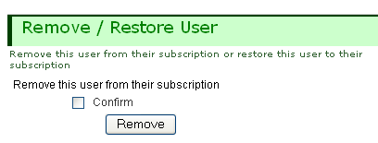
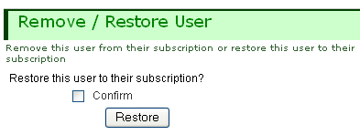

Be sure to check “confirm” before updating or the system will not honor the update.

If a user was deleted in error, they can be restored within 7 days, after which time the delete becomes permanent.

Change the administrator of a subscription
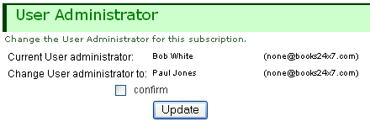
Find the user that you would like to be the administrator of the subscription. Click on Manage User, and go to the User Administrator section of the page.

Be sure to check “confirm” before updating or the system will not honor the update.

Make a User a Corporate Folder (CFA) or Corporate Topic (CTA) Administrator
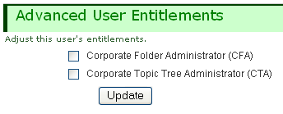
After looking up the user, go to the Advanced User Entitlements section of the Manage User page. Select CFA and/or CTA and click Update. There is no limit to the number of users that can be designated CFAs or CTAs.

Give User access to the User Reporting Site
After looking up the user, go to the Assign User Report Access section of the Manage User page. There is no limit to the number of users that can have access to the Books24x7 reporting site.
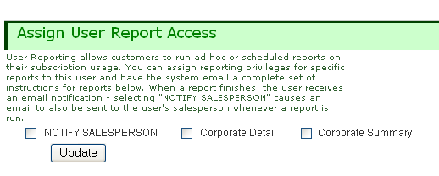

Use the “NOTIFY SALESPERSON” option to have a notice sent to the salesperson listed in the system each time a report is run.

Run reports for a subscription
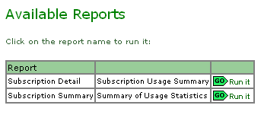
Lookup the account you would like to report on and click on the Advanced Report button.

Once you get to that page you need to choose the report you would like to run. Enter the requested data and Click Run.

It is important to note that your report will not be available immediately; it will be put in to a queue. When it is done it will show up under “Available Results” as being completed. The person who logged in and ran the report will also receive notice by e-mail.

Once the report is completed, you need to click on view results. You can also download the report into excel so it is easy to send to the customer. Each report you run will show up in “Available Results” so you can see the past reports you have run.

See Report Index for an explanation of each available report.

Report Index

Subscription Detail - Subscription Usage Report
Summary of subscription usage including top titles, hottest topics and frequent searches; also includes individual usage summary for each user.

Input: date range

Output:
- Current Sub stats: total seats, start/end dates, collections
- Collection seat usage: collections, #seat, #seats taken
- Stats for date range: # new users registered, # active users
- Usage Stats for date range: # sessions, # minutes, #HTML pages reads, # unique titles accessed
- Individual User stats (Occupied and Soft-Deleted seats): name, login, email, # sessions, # minutes, # HTML page reads, last login, date registered, collection(s)
- Top titles (up to 25 per collections): collection, title, copyright, ISBN, # HTML Page reads, # PDF downloads
- Top topics: Collection, HTML Page reads, Topic
Top Searches: # of searches, search string

Subscription Summary - Summary of Usage Statistics
Summary of subscription usage including top titles, hottest topics and frequent searches

Input: date range

Output:
- Current Sub stats: total seats, start/end dates, collections
- Collection seat usage: collections, #seat, #seats taken
- Stats for date range: # new users registered, # active users
- Usage Stats for date range: # sessions, # minutes, #HTML pages reads, # unique titles accessed
- Top titles (up to 25 per collections): collection, title, copyright, ISBN, # HTML Page reads, # PDF downloads
- Top topics: Collection, HTML Page reads, Topic
- Top Searches: # of searches, search string

